Chapter 11 - Section 4 (1)(b)(xi) of the Right to Information Act, 2005

The Budget Allocated to each Agency, including the particulars of all plans, proposed expenditures and reports on disbursement made

Please Scan and paste the pdf file of Form X– Receipts and Expenditure
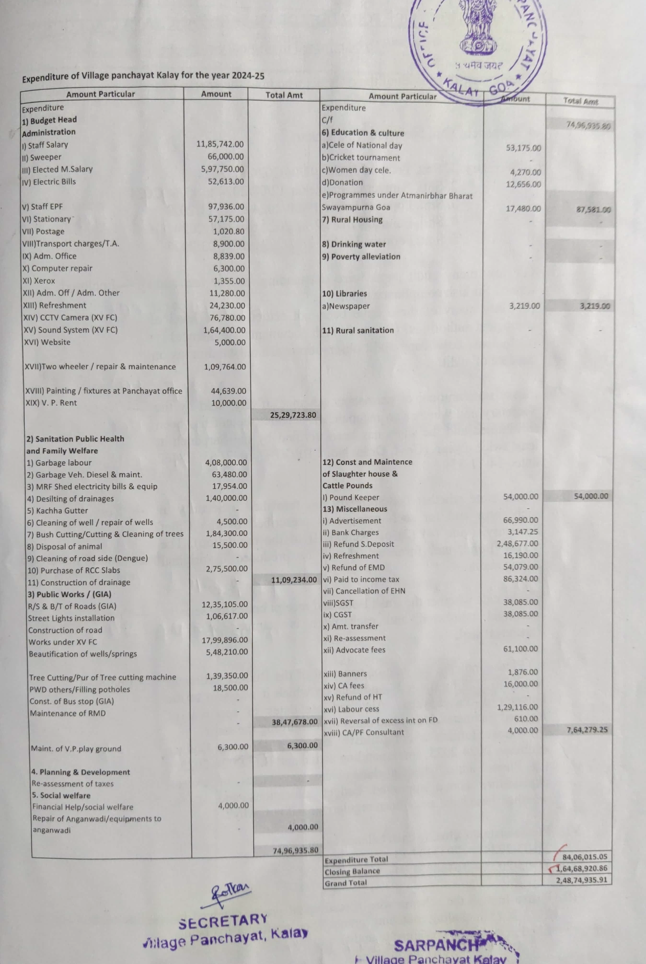

Please Scan and paste the pdf file of Form XI – Budget
